Software Requirements Specification
for
T.A. Solutions
Version 1.0
Prepared by Brian Blondet
Kean University
February 25, 2020
Table of Contents
Table of Contents ii
Revision History ii
1. Introduction 1
1.1 Purpose 1
1.2 Document Conventions 1
1.3 Intended Audience and Reading Suggestions 1
1.4 Product Scope 1
1.5 References 2
2. Overall Description 2
2.1 Product Perspective 2
2.2 Product Functions 3
2.3 User Classes and Characteristics 5
2.4 Operating Environment 6
2.5 Design and Implementation Constraints 7
2.6 User Documentation 7
2.7 Assumptions and Dependencies 7
3. External Interface Requirements 8
3.1 User Interfaces 8
3.2 Hardware Interfaces 8
3.3 Software Interfaces 9
3.4 Communications Interfaces 9
4. System Features 9
4.1 System Feature 1 9
4.2 System Feature 2 (and so on) 10
5. Other Nonfunctional Requirements 10
5.1 Performance Requirements 10
5.2 Safety Requirements 10
5.3 Security Requirements 10
5.4 Software Quality Attributes 11
5.5 Business Rules 11
6. Other Requirements 11
Appendix A: Glossary 11
Appendix B: Analysis Models 11
Appendix C: To Be Determined List 11
functional requirements for the product by system features, the major services provided by the product. You may prefer to organize this section by use case, mode of operation, user class, object class, functional hierarchy, or combinations of these, whatever makes the most logical sense for your product.>

Revision History
Name | Date | Reason For Changes | Version
Brian Blondet | 2/25 | Baseline | 1.0

Introduction

Purpose
The purpose of this document is to provide a detailed specification of the software system, T.A. Solutions. The product to be a web and android mobile application that will streamline the check-in/out process for tutors and students as well as log all their activity to provide administration with analytics of the tutoring and subject

<Identify the product whose software requirements are specified in this document, including the revision or release number. Describe the scope of the product that is covered by this SRS, particularly if this SRS describes only part of the system or a single subsystem.>

Document Conventions
Area | Font | Size
Section | Times | 18
Subsection | Times | 14
Contents | Times | 12
Table of contents subsections | Times | 11
Header & Footer | Times | 11

Currently highlighting conveys my sadness and whether the section was complete

<Describe any standards or typographical conventions that were followed when writing this SRS, such as fonts or highlighting that have special significance. For example, state whether priorities for higher-level requirements are assumed to be inherited by detailed requirements, or whether every requirement statement is to have its own priority.>

Intended Audience and Reading Suggestions
This document contains a high-level description of T.A. Solutions product and is intended as a guideline for the development team.

<Describe the different types of reader that the document is intended for, such as developers, project managers, marketing staff, users, testers, and documentation writers. Describe what the rest of this SRS contains and how it is organized. Suggest a sequence for reading the document, beginning with the overview sections and proceeding through the sections that are most pertinent to each reader type.>

Product Scope
T.A. Solutions seeks provide administrators of tutoring programs a means to easily monitor their program by digitally logging sessions, automated flagging, and data analytics, while also streamlining the sign-in process for both Student and Tutor through mobile and web-based systems. As a result, T.A. Solutions will aid administrative decision making by informing users of issues within the program and predicting program growth.

By the end of the timeline there should be a successful development of the following:
- Mobile App
- Web application
- Analytics and reports
- Data processing/Analytic Tools
There should be successfully tested the system by either deploying it to code samurai or a
small tutoring group.

<Provide a short description of the software being specified and its purpose, including relevant benefits, objectives, and goals. Relate the software to corporate goals or business strategies. If a separate vision and scope document is available, refer to it rather than duplicating its contents here.>

References
Guide to creating Software Requirement Specification by Karl E. Wiegers.

<List any other documents or Web addresses to which this SRS refers. These may include user interface style guides, contracts, standards, system requirements specifications, use case documents, or a vision and scope document. Provide enough information so that the reader could access a copy of each reference, including title, author, version number, date, and source or location.>

Overall Description

Product Perspective
T.A. Solutions aims to be integrated to an existing tutoring program(s) at any university by taking over the check in/out process for both students and tutors. By taking over these processes those overseeing the tutoring program will be able to view the digital logs and data analytics provided by our product. This product is intended to be used on Android and web application, however administrative functions for the admin and supervisors will be only available on web. If a supervisor were to login to mobile, they would be brought to the tutor by default.

<Describe the context and origin of the product being specified in this SRS. For example, state whether this product is a follow-on member of a product family, a replacement for certain existing systems, or a new, self-contained product. If the SRS defines a component of a larger system, relate the requirements of the larger system to the functionality of this software and identify interfaces between the two. A simple diagram that shows the major components of the overall system, subsystem interconnections, and external interfaces can be helpful.>

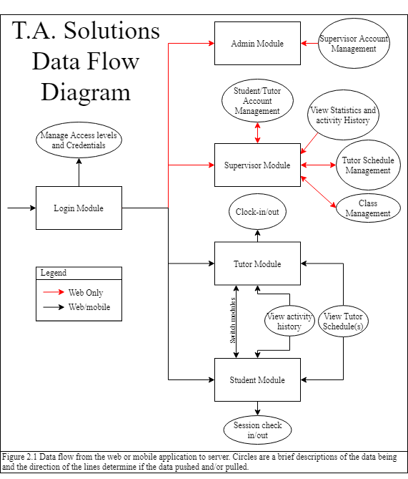
Product Functions

- One admin with a module on web and direct access to the database systems.
- User logging in with valid credentials will be brought to appropriate modules.
- Admin and Supervisor modules will have all their functionality on the web application.
- If an admin or supervisor were to login on mobile, the tutor module will be their default view.

- Admin Module:
  - Supervisor Account Management: Allows admin to promote/demote supervisor privilege to existing users.
- Supervisor Module:
  - Student/Tutor Account Management: Allows supervisor to promote/demote users between student and tutor using their email. Tutor permissions should only last one semester.
  - View Statistics and Activity History:
    - View and edit check in/out of students.
    - View and edit clock in/out of tutors.
    - Edits should be logged to database.
    - View will have graphics with parameters that can be edited.
    - Tutor Analytics based off activity history.
  - Tutor Schedule Management: Sets tutor user schedules and the classes they are proficient in.
  - Class Management:
    - Create or delete classes that will be listed under tutors. Must include Class name, ID, and description.
    - An option to require tutoring to take place at specific GPS location.
- Tutor Module:
  - Clock in/out: Digitally log tutor clock in/out to the MySQL Database.
  - Tutor Clock in will create a QR code and alphanumeric code for students to check in/out.
  - View Tutor Schedule(s): view personal schedule or schedule of all tutors.
  - View Activity History: view clock in/out history or tutoring history.
- Student Module:
  - Session Check in/out: Student must use a code or QR code provided by the tutor. If GPS checking is enabled the program will compare GPS coordinates and store a Boolean. No GPS coordinates will be stored.
  - View Activity History: view tutoring session history.
  - View Tutor Schedule: view schedule of all tutors.

<Summarize the major functions the product must perform or must let the user perform. Details will be provided in Section 3, so only a high-level summary (such as a bullet list) is needed here. Organize the functions to make them understandable to any reader of the SRS. A picture of the major groups of related requirements and how they relate, such as a top level data flow diagram or object class diagram, is often effective.>

User Classes and Characteristics
Admin is anticipated to be a member of the IT department of a university or school system adopting T.A. Solutions. They will need experience in MySQL and with webservers for installing the T.A. Solutions web application. The other users do not require strong technical backgrounds

Supervisors are expected to be from different departments of a university and running the tutoring program for said department. I.E. Computer science, Mathematics, Biology. User is expected to be a power user because they will be responsible for scheduling tutors and checking their hours.

Tutors will be regularly using T.A. Solutions software for digitally logging their work hours and providing a means to check into sessions for students looking for their services.

Student users will vary in use depending on if they are seeking tutoring for their classes. Furthermore, they must use a tutor’s QR code or alphanumeric code to check in to their session.

T.A. solutions user hierarchy will allow the topmost users to promote users below to other access levels below their own (Figure 2.2). New users will be Students by default, until they are granted other permissions. Admin permissions must be granted by developers.
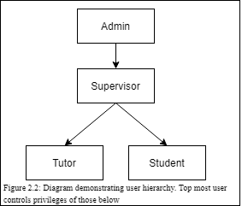

<Identify the various user classes that you anticipate will use this product. User classes may be differentiated based on frequency of use, subset of product functions used, technical expertise, security or privilege levels, educational level, or experience. Describe the pertinent characteristics of each user class. Certain requirements may pertain only to certain user classes. Distinguish the most important user classes for this product from those who are less important to satisfy.>

Operating Environment
T.A. Solutions is an open source web and android mobile application that requires a webserver and MySQL server. The web application can run on Google Chrome, Microsoft Edge, and Firefox.

<Describe the environment in which the software will operate, including the hardware platform, operating system and versions, and any other software components or applications with which it must peacefully coexist.>

Design and Implementation Constraints
Currently there are no plans for development in Apple’s mobile IOS.

<Describe any items or issues that will limit the options available to the developers. These might include: corporate or regulatory policies; hardware limitations (timing requirements, memory requirements); interfaces to other applications; specific technologies, tools, and databases to be used; parallel operations; language requirements; communications protocols; security considerations; design conventions or programming standards (for example, if the customer’s organization will be responsible for maintaining the delivered software).>

User Documentation
FAQ page and help page will be available on the web application.

<List the user documentation components (such as user manuals, on-line help, and tutorials) that will be delivered along with the software. Identify any known user documentation delivery formats or standards.>

Assumptions and Dependencies
Not sure about this section?

<List any assumed factors (as opposed to known facts) that could affect the requirements stated in the SRS. These could include third-party or commercial components that you plan to use, issues around the development or operating environment, or constraints. The project could be affected if these assumptions are incorrect, are not shared, or change. Also identify any dependencies the project has on external factors, such as software components that you intend to reuse from another project, unless they are already documented elsewhere (for example, in the vision and scope document or the project plan).>

External Interface Requirements

Mobile User Interfaces

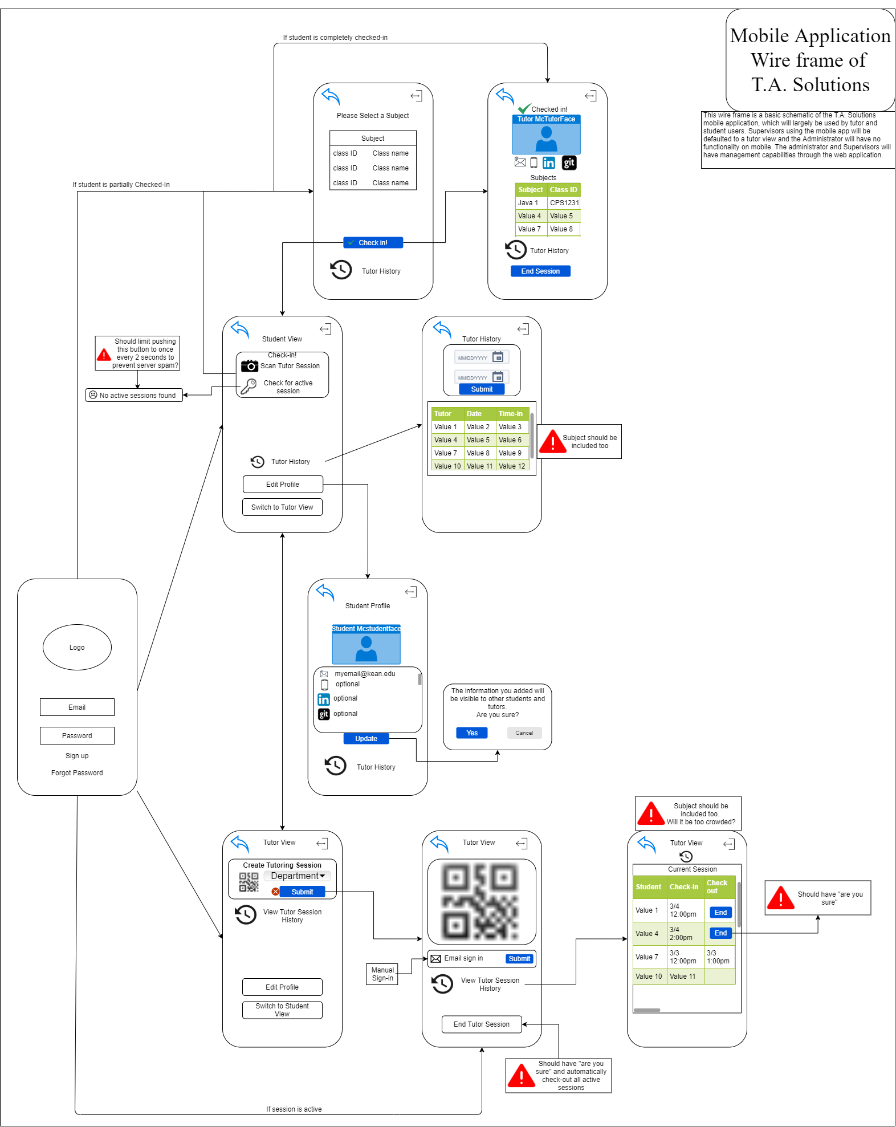

<Describe the logical characteristics of each interface between the software product and the users. This may include sample screen images, any GUI standards or product family style guides that are to be followed, screen layout constraints, standard buttons and functions (e.g., help) that will appear on every screen, keyboard shortcuts, error message display standards, and so on. Define the software components for which a user interface is needed. Details of the user interface design should be documented in a separate user interface specification.>

System Features

<This template illustrates organizing the System Feature 1

<Don’t really say “System Feature 1.” State the feature name in just a few words.>
4.1.1 Description and Priority
<Provide a short description of the feature and indicate whether it is of High, Medium, or Low priority. You could also include specific priority component ratings, such as benefit, penalty, cost, and risk (each rated on a relative scale from a low of 1 to a high of 9).>
4.1.2 Stimulus/Response Sequences
<List the sequences of user actions and system responses that stimulate the behavior defined for this feature. These will correspond to the dialog elements associated with use cases.>
4.1.3 Functional Requirements
<Itemize the detailed functional requirements associated with this feature. These are the software capabilities that must be present in order for the user to carry out the services provided by the feature, or to execute the use case. Include how the product should respond to anticipated error conditions or invalid inputs. Requirements should be concise, complete, unambiguous, verifiable, and necessary. Use “TBD” as a placeholder to indicate when necessary information is not yet available.>

<Each requirement should be uniquely identified with a sequence number or a meaningful tag of some kind.>

REQ-1:
REQ-2:

System Feature 2 (and so on)

Other Nonfunctional Requirements

Performance Requirements
<If there are performance requirements for the product under various circumstances, state them here and explain their rationale, to help the developers understand the intent and make suitable design choices. Specify the timing relationships for real time systems. Make such requirements as specific as possible. You may need to state performance requirements for individual functional requirements or features.>

Safety Requirements
<Specify those requirements that are concerned with possible loss, damage, or harm that could result from the use of the product. Define any safeguards or actions that must be taken, as well as actions that must be prevented. Refer to any external policies or regulations that state safety issues that affect the product’s design or use. Define any safety certifications that must be satisfied.>

Security Requirements
<Specify any requirements regarding security or privacy issues surrounding use of the product or protection of the data used or created by the product. Define any user identity authentication requirements. Refer to any external policies or regulations containing security issues that affect the product. Define any security or privacy certifications that must be satisfied.>

Software Quality Attributes
<Specify any additional quality characteristics for the product that will be important to either the customers or the developers. Some to consider are: adaptability, availability, correctness, flexibility, interoperability, maintainability, portability, reliability, reusability, robustness, testability, and usability. Write these to be specific, quantitative, and verifiable when possible. At the least, clarify the relative preferences for various attributes, such as ease of use over ease of learning.>

Business Rules
<List any operating principles about the product, such as which individuals or roles can perform which functions under specific circumstances. These are not functional requirements in themselves, but they may imply certain functional requirements to enforce the rules.>

Other Requirements
<Define any other requirements not covered elsewhere in the SRS. This might include database requirements, internationalization requirements, legal requirements, reuse objectives for the project, and so on. Add any new sections that are pertinent to the project.>
Appendix A: Glossary
- SDD - Software Design Document
- UI - User Interface
- PHP - Personal Home Page, a server-side scripting Language
- HTML - HyperText Markup Language, for web browser UI
- CSS - Cascading Style Sheets, for UI

<Define all the terms necessary to properly interpret the SRS, including acronyms and abbreviations. You may wish to build a separate glossary that spans multiple projects or the entire organization, and just include terms specific to a single project in each SRS.>
Appendix B: Analysis Models
<Optionally, include any pertinent analysis models, such as data flow diagrams, class diagrams, state-transition diagrams, or entity-relationship diagrams.>
Appendix C: To Be Determined List
<Collect a numbered list of the TBD (to be determined) references that remain in the SRS so they can be tracked to closure.>

